
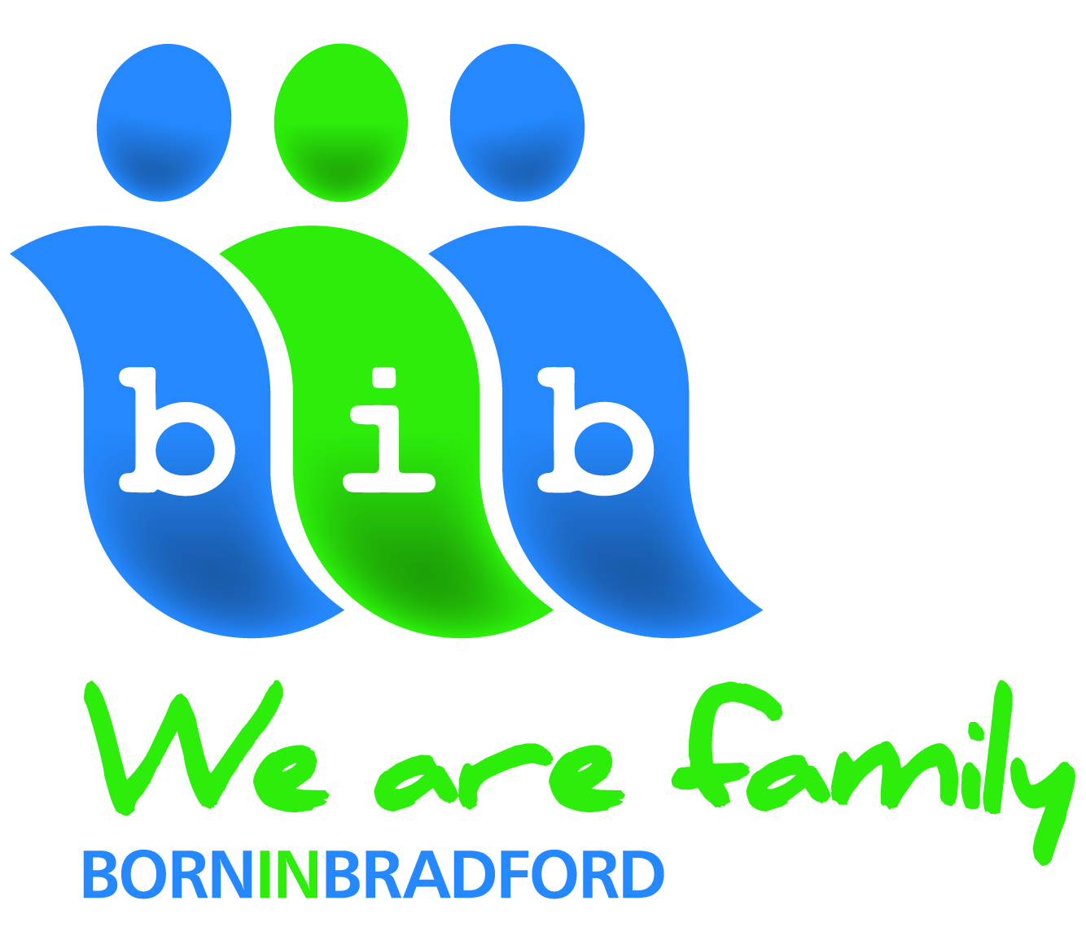

Parent Information Sheet
Born in Bradford: The Primary School Years

Born in Bradford researchers are carrying out assessments that will show the learning ability, working memory capacity, and well-being of children in Y3, Y4 and Yr 5. The assessments will indicate which children are struggling in class and will pick up where their difficulties lie, for example in their fine motor control, their language skills or their working memory. These assessments are free to Bradford schools.

What will we do?
The assessments will be carried out during normal school hours with groups of 8 -10 children at a time, under the supervision of 5 researchers. The assessments will take 40-45 minutes to complete.

The assessments are presented to the children as ‘games’ using a special touch screen computer and stylus pen. Children will complete 3 tasks that measure the kind of fine motor skills needed for handwriting, drawing and using scissors
- A ‘tracing’ task where the child follows a path on screen with the stylus pen while staying within the lines of the path shown.
- A ‘tracking’ task where the child follows a dot moving around the screen in a figure-of-8 pattern.
- An ‘aiming’ task where the child follows a dot by moving the pen, as the dot moves quickly from one position to another.

Memory is measured by asking the child to remember, for example, a sequence of numbers and to keep them in their memory whilst doing other tasks.

How quickly a child can process information is measured by asking them to count, for example, the number of red circles on the screen as fast as they can.

The children will also be asked to fill in a short questionnaire about their well-being and happiness. The questions ask them about how they feel about their lives, about their family and where they live, their schools, their friends, about the kinds of things they own (clothes, phones) and the kind of job they would like as an adult. None of these questions are distressing to answer. The questionnaire is done under the supervision of our researchers; it takes 15 minutes to complete.

What happens to the information?
- The assessments will be kept confidential and will only be used for research.
- We would like to link the results of these assessments to routinely collected education data collected by the school.
- All the information will be held by the Born in Bradford study and will be stored with a study code (rather than a name) so that it will not be possible for anyone to see information connected to your child.
- Assessment information will be analysed anonymously and results will be reported anonymously so it will not be possible to identify an individual child.
- None of your child’s information will be passed on to any other organisation not directly involved in this study.

Who is leading the project?
This project is being led by Professor John Wright and the Born in Bradford study team with guidance and help from Primary School Head Teachers in Bradford. The study has been reviewed and approved by Bradford Research Ethics Committee [Ref 16/YH/0062, 24 March 2016].

How can I find out more information?
If you would like to find out more about the study before deciding to let your child take part , or if at a later date you would like to withdraw your child from the study please telephone Dr Katy Shire at Born in Bradford, on 01274 36 4474 or by email Katy.Shire@bthft.nhs.uk You can also access our website www.borninbradford.nhs.uk or follow us on Facebook or Twitter if you would like to know more about the study.

How will I find out the results of the study?
The results of this study will be published in scientific journals but we will also make sure that they are included in our newsletters and are available through our website.

What do I need to do if I would like my child to have the assessments?
If you are happy for your child to take part you DO NOT NEED TO DO ANYTHING.

What do I need to do if I do not want my child to have the additional assessments?
There is no obligation for your child to take part and if you DO NOT want your child to have assessments please fill in the attached Refusing Consent Form and return it to school. If you do not return the refusing consent form we will assume that you are happy for your child to be assessed.

