The IRL trial: Feasibility testing summary

What we did
Feasibility testing for the IRL trial commenced in May 2026. A single, state-funded secondary school in Bradford, UK was recruited. All students in academic years 8 (ages 12-13), 9 (ages 13-14), and 10 (ages 14-15) were eligible to participate. Participants whose parents/carers had not opted out were invited to provide opt-in consent when the research team attended for the baseline session.
Those that opted-in completed a baseline questionnaire and installed the intervention app on their phones. Participants in year 8 were assigned to the control group and had no restrictions. Those in year 9 were assigned to a 2-hour daily limit to linked apps (including TikTok, Snapchat, YouTube, and Instagram), and those in year 10 were assigned to a 1-hour daily limit. Participants in both years 9 and 10 were also given a night-time curfew, restricting use of linked apps between 9pm and 7am. Participants were able to override restrictions each day, but this affected their score on a leaderboard.
The trial lasted 6 weeks. The research team returned in June 2026 to conduct follow-up surveys and uninstall the app. Participants, blind to the number of participating schools, received a £10 voucher and told the most adherent school would win £5000.

What we found
Attrition at each stage is displayed in Figure 1. There were 525 participants in the target population, of whom 33 (6.3%) opted out. Of the remaining eligible participants, 224/492 (45.5%) provided opt-in consent and submitted a baseline survey. Approximately 35% failed to complete the baseline survey in the 10-minutes allotted to them (Figure 2). At follow-up, participants were allotted 20-minutes where missing rates were less than 5% for all items (Figure 3).
The time discrepancy was attributed to technical difficulties installing iOS versions of the intervention app, which also led to unreliable app usage data from Apple devices. Android users in the control group spent approximately 5.25 hours using linked apps each day. Approximately 80% year 8s kept the app installed for the full duration of the trial, 50% year 9s (2-hour limit), and 25% year 10s (1-hour limit), of which 66.7% (year 9) and 50% (year 10) adhered to restrictions. Despite the social media ban for under 16s being announced during the trial, more than 75% participants said the research was important.

What it means for the trial
The largest loss of participants occurred at the opt-in stage. The prevailing feeling among those lost was £10 wasn’t enough and individual performance-based incentives were necessary. In the full trial, all participants will receive a £20 voucher and those in the intervention group will earn tickets into a prize draw for a £100 voucher based on their adherence, in addition to the school-based incentive.
iOS onboarding will be simplified through further app development. This will yield an additional 10-minutes for questionnaires and bring completion rates to follow-up standards.
Finally, the daily restriction will be set at 2-hours. This will further discourage participants from uninstalling the app from their phones. This represents a significant reduction in daily screentime, which was over 5-hours in the control group.
Realistically, we hope to recruit ~75% of eligible students with 66% adherence. This would represent 50% of the entire year (including non-participants) successfully restricting their usage.
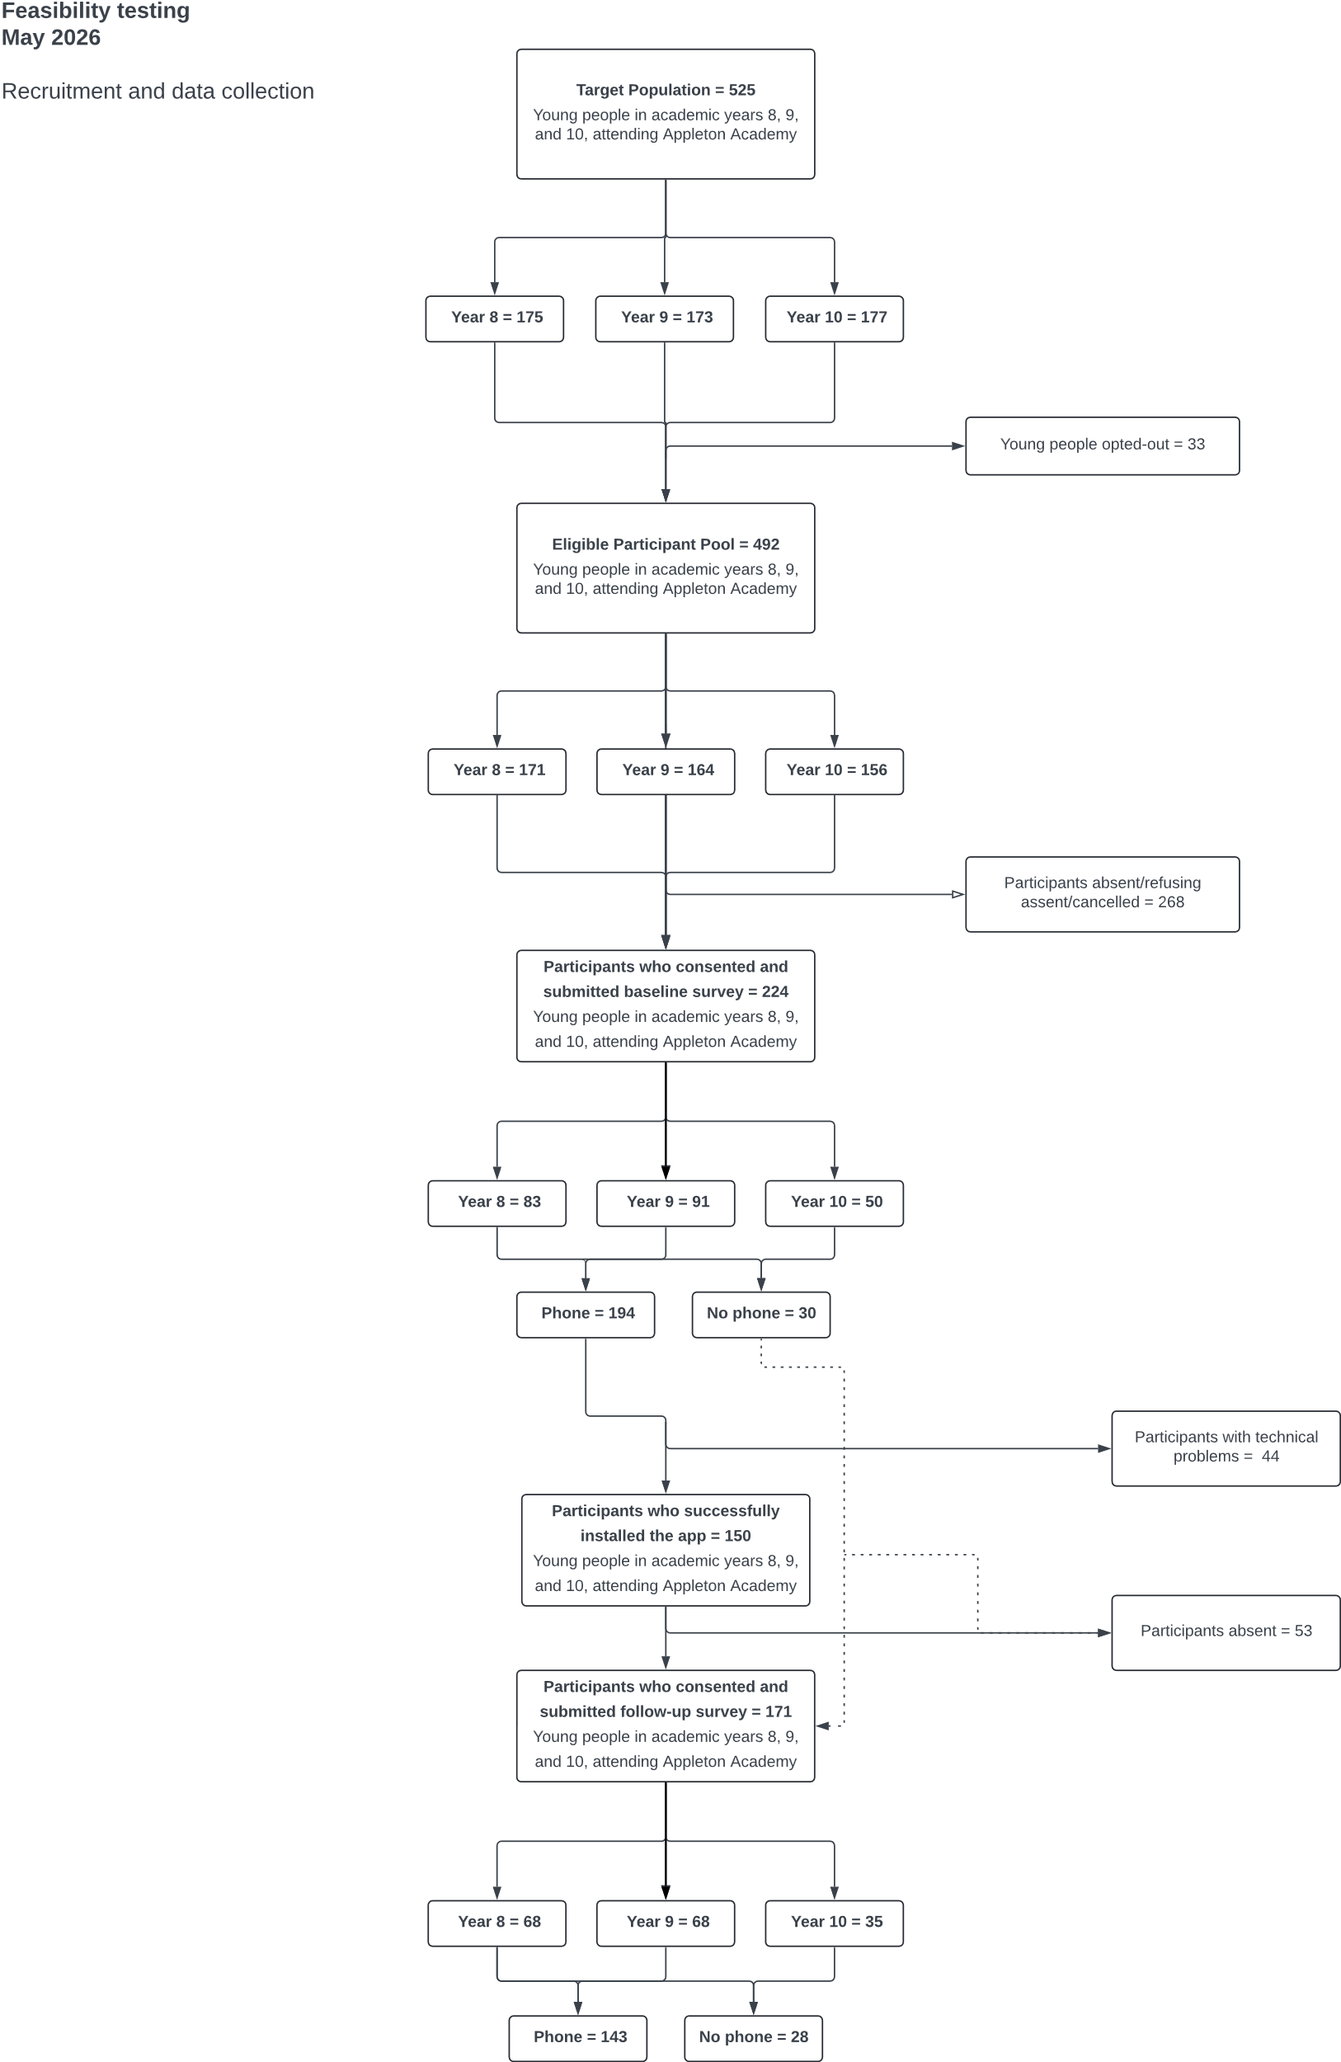
Figure 1 Participant flow.

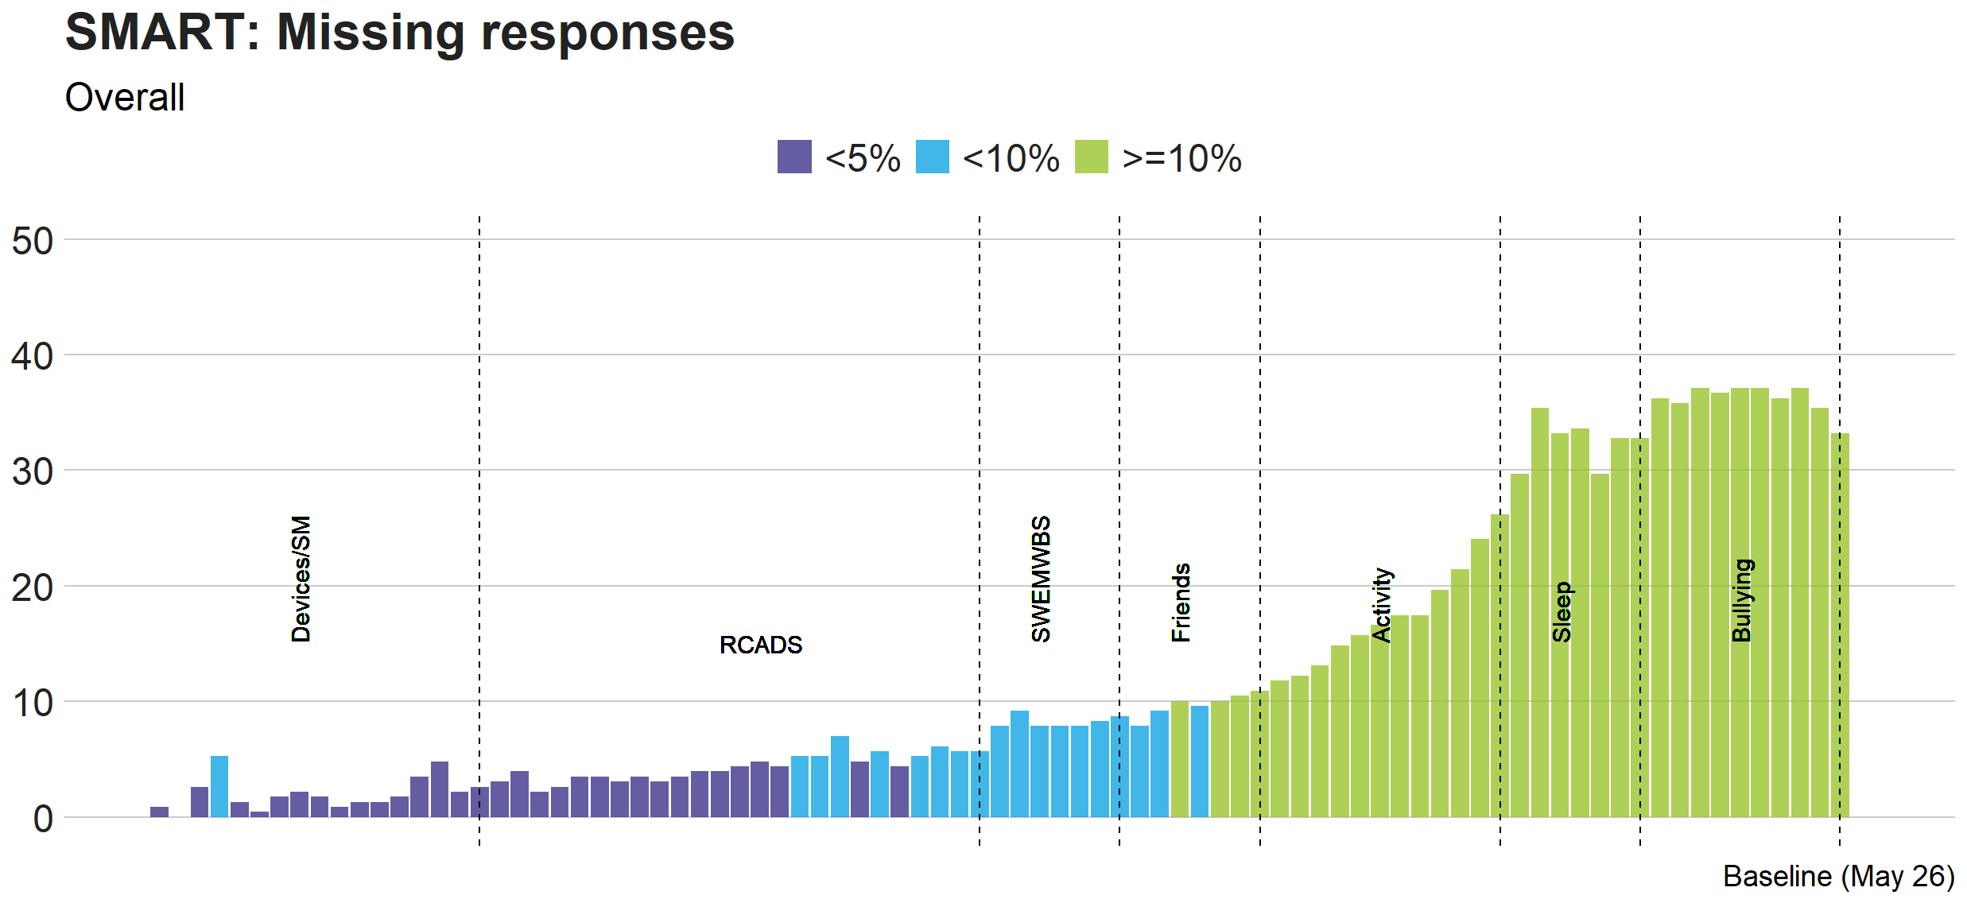
Figure 2. Proportion of survey responses that were missing at baseline. Items are displayed from left-right in the order they appeared on the survey.

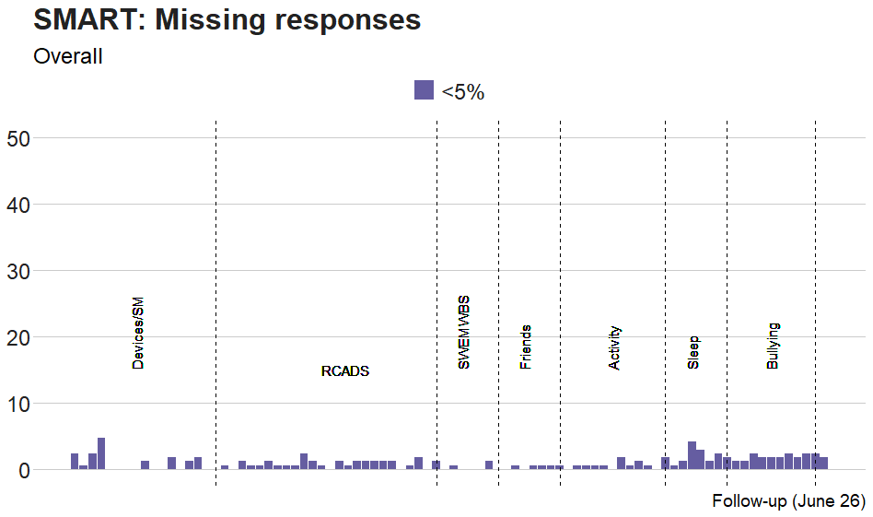
Figure 3. Proportion of survey responses that were missing at follow-up. Items are displayed from left-right in the order they appeared on the survey.

