What We Measure in the Study – Children
We collect a range of measures from children, parents, and teachers to better understand health, wellbeing, and development. Below is a summary of what we do, why, and how long it takes.
Participant | Measure | Description | Approx. Duration
Child | Child Wellbeing Survey  View full questionnaire | A survey about wellbeing, health, and daily life, completed by the child. | 30–45 minutes
Child | OxEd Reading Screen  More info  For more information on the reliability and validity of the measure please see below. | The Reading Screen tests reading skills for children aged 5 – 12 years via tablet. This includes 60 word reading items (ability to recognise words) and 34 nonword reading (ability to decode unfamiliar words) The teacher or administering adult guides the child through the tests using the instructions provided, marking their responses discretely as correct or incorrect on the tablet. You can see examples of each of these below:  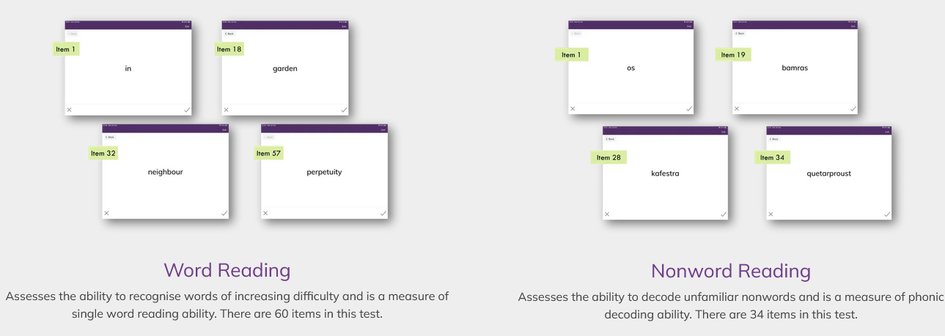  Adjusts to the child’s age/ability.  The child’s school will get an assessment report with age-standardised results, visual and written feedback for individual pupils and classes, and traffic light symbols showing children who would benefit most from support. | 2–10 minutes
Child | OxEd Language Screen  More info  For more information on the reliability and validity of the measure please see below. | The Language Screen tests oral language skills for children aged 3.5 to 11 years via tablet. This includes expressive vocabulary (what does each picture show?), listening comprehension (answer questions about short stories), receptive vocabulary (which picture matches the word you hear?), and sentence repetition (repeat the sentence you hear and see). The teacher or administering adult guides the child through the tests using the instructions provided, marking their responses discretely as correct or incorrect on the tablet. You can see examples of each of these below:  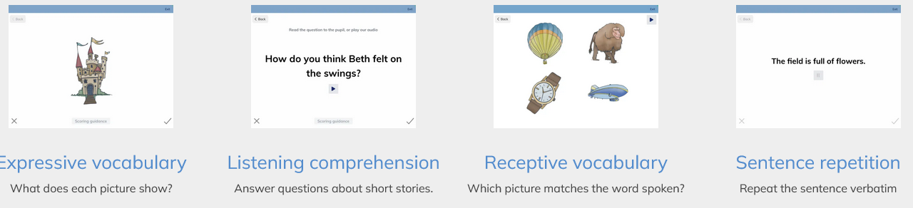  Adjusts to the child’s age/ability.  The child’s school will get an assessment report with age-standardised results, visual and written feedback for individual pupils and classes, and traffic light symbols showing children who would benefit most from support. | <10 minutes
Child | Height | Measured using a Leicester stadiometer (without shoes). | 1–2 minutes
Child | Weight & Body Composition | Measured using a Tanita bioelectrical impedance scale to estimate fat, muscle, and water mass. | 2 minutes
Child | Waist Circumference | Measured using a stretch-resistant tape. Children can choose whether to lift their top or take part. | 2 minutes
Child | Blood Pressure & Pulse | Two seated blood pressure readings taken with an electronic monitor. A third reading is taken if results are elevated, with follow-up action if necessary. | 3–5 minutes
Child | Family Drawing | Children draw their family in a booklet (optional). We may take a photo of the drawing (with permission). | ~5-10 minutes
Child | School Lunch Observation  For papers where this has been validated in other primary school children, please see: Article 1 & Article 2 | Trained staff photograph school lunches before and after eating to estimate food intake. | Occurs during lunchtime
Teacher | Strengths and Difficulties Questionnaire (SDQ): More Info | Teachers complete a 25-item behavioural questionnaire about each participating child. Covers behaviour, emotions, attention, and peer relationships. | Flexible (at teacher’s convenience)

Are the language measures reliable and valid?
Both Language Screen and Reading Screen were developed by Professor Charles Hulme, a language and reading expert who created the Nuffield Early Language Intervention Programme. The Language Screen was standardised on approximately 350,000 children aged approximately 3 – 9 years old, correlates with longer well-standardised tests of language ability (such as the Clinical Evaluation of Language Fundamentals and the Renfrew Action Picture Test) and showed good-to-excellent reliability for the total scale. An in-depth summary can be found here: https://oxedandassessment.com/research/evidence-assessments-interventions/#LanguageScreen and here: Hulme, C., McGrane, J., Duta, M., West, G., Cripps, D., Dasgupta, A., Hearne, S., Gardner, R., & Snowling, M. (2024). LanguageScreen: the development, validation and standardization of an automated language assessment app. Language, Speech, and Hearing Services in Schools, 55(3), 904–917. Reading Screen is being used to assess the Nuffield Early Language Intervention Programme alongside Language Screen and is currently undergoing evaluation (https://doi.org/10.1186/ISRCTN15660056), but uses well-known established measures of reading called ‘word reading’ and ‘non word reading’ (see de Jong, P. F., & van der Leij, A. (2002). Effects of Phonological Abilities and Linguistic Comprehension on the Development of Reading. Scientific Studies of Reading, 6(1), 51–77; Mani & Huettig, 2014, Journal of Experimental Child Psychology, 126, 264 – 279).

