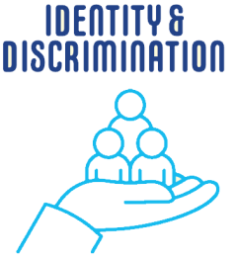
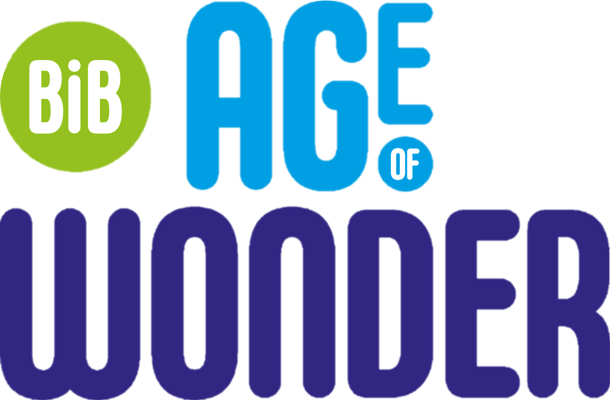
MODULE FOUR
CONTENT
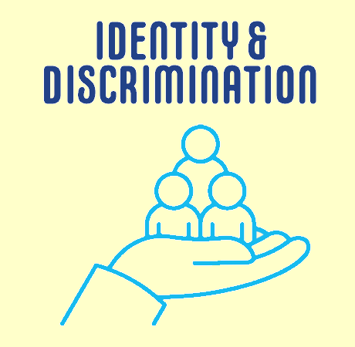
Section 1: School
School Environment
Behaviour
Encouraging
School Experience
School Pressure
Friends
Section 2: Identity and Discrimination
Attitudes and Values
Migration
Bullying
Discrimination
Section 3: Digital and Social Media
Social Media
Digital Devices at School
Online Materials
Digital Devices at Home
Internet
Digital Learning
Attitudes towards Technology

1 | Participant Study ID
2 | Year Group
Section 1: School

School Environment
In this part of the survey you will be asked questions about your school.
Remember, your answers are completely confidential so please be as honest as you can. If you do not want to answer a question, you can skip it.

Item no | Item | Response
3 | I enjoy school | All the time | Most of the time | Some of the time | Almost Never | Never
4 | Teachers help me to do my best | In every lesson | In most lessons | In some lessons | In very few lessons | In none of my lessons
5 | My teachers give me work that challenges me | In every lesson | In most lessons | In some lessons | In very few lessons | In none of my lessons
6 | I enjoy learning at this school | All the time | Most of the time | Some of the time | Almost Never | Never
7 | Teachers listen to what I have to say in lessons | Strongly agree | Agree | Neither agree nor disagree | Disagree | Strongly disagree
8 | There is an adult at school I can talk to if something is worrying me | Strongly agree | Agree | Neither agree nor disagree | Disagree | Strongly disagree
Behaviour
In this part of the survey you will be asked questions about how people behave at school. Remember, nobody will know how you've responded and if you do not want to answer a question, you can skip it.

Item no | Item | Response
9 | The behaviour of other pupils in my lessons is good | All the time | Most of the time | Some of the time | Almost Never | Never
10 | The behaviour of other pupils around school is good | All the time | Most of the time | Some of the time | Almost Never | Never
11 | Is bullying a problem at your school? | It doesn't happen | It happens and teachers are really good at resolving it | It happens and teachers are good at resolving it | It happens and teachers are not good at resolving it | It happens and teachers do nothing about it
12 | I feel safe when I am at school | All the time | Most of the time | Some of the time | Almost Never | Never
13  Encouraging  Positive Behaviours In this part of the survey you will be asked questions about the behaviours your school encourages. Remember, if you do not want to answer a question, you can skip it. To what extent do you agree or disagree with the following statements: | Do you think your school takes bullying seriously? | No | Not Sure | Yes

Item no | Item |  | Response
14 | My school encourages me to look after my physical health (for example, healthy eating and fitness) |  | Strongly agree | Agree | Neither agree nor disagree |  | Disagree |  | Strongly disagree
15 | My school encourages me to look after my emotional and mental health |  | Strongly agree | Agree | Neither agree nor disagree |  | Disagree |  | Strongly disagree
16 | My school encourages me to be independent and to take on responsibilities |  | Strongly agree | Agree | Neither agree nor disagree |  | Disagree |  | Strongly disagree
17 | My school encourages me to respect people from other backgrounds and to treat everyone equally |  | Strongly agree | Agree | Neither agree nor disagree |  | Disagree |  | Strongly disagree
School Experience
In this part of the survey you will be asked questions about your school experience. Remember, if you do not want to answer a question, you can skip it.

Item no | Item | Response
18 | My school provides me with information about my next steps (For example: moving year group or school, choosing qualifications for the future, going to university or other education and training options like apprenticeships, or finding a job) | Yes, but it was too much information and was not helpful |  | Yes, I received the right amount of information that was helpful |  | Yes, but there wasn't enough information that was helpful |  | No, I haven't received any information
19 | Are you able to get water at school? | Yes |  | No |  | Not easily
20 | If you can, where can you get it from? | Text box
School Pressure
How much do you agree or disagree with the following statements.

Item no | Item | Response
21 | Competition with other people for grades is intense | Strongly agree |  | Agree |  | Neither agree nor disagree | Disagree | Strongly disagree
22 | If I don't do well in school, my family will be disappointed | Strongly agree |  | Agree |  | Neither agree nor disagree | Disagree | Strongly disagree
23 | My teachers put too much pressure on me to do well in school | Strongly agree |  | Agree |  | Neither agree nor disagree | Disagree | Strongly disagree
24 | I'm worried about progressing in the future | Strongly agree |  | Agree |  | Neither agree nor disagree | Disagree | Strongly disagree
25 | If I don't do well in school, I'll be a failure | Strongly agree |  | Agree |  | Neither agree nor disagree | Disagree | Strongly disagree
26 | I often feel stressed because of the pressure to do well in school | Strongly agree |  | Agree |  | Neither agree nor disagree | Disagree | Strongly disagree
27 | I worry about doing well in tests, exams and assessments | Strongly agree |  | Agree |  | Neither agree nor disagree | Disagree | Strongly disagree
28 | I have too many tests, exams and assessments | Strongly agree |  | Agree |  | Neither agree nor disagree | Disagree | Strongly disagree
Friends

Item no | Item |  | Response
29 | How many in-person friends do you have?  *By in-person, we mean friends you've met in real life |  | Not many |  | Sometimes |  | Lots
30 | How many online friends do you have?  *By online, we mean friends you only know online |  | Not many |  | Sometimes |  | Lots
31 | Do you have any close friends?  *By close friends we mean other young people you feel at ease with or who you can talk to about things that are private |  | Yes |  | No
32 | How many of your close friends are from the same ethnic group? |  | All of them |  | Most of them |  | Some of them |  | None of them
33 | How many of your close friends work hard at school? |  | All of them |  | Most of them |  | Some of them |  | None of them
34 | How many of your close friends get into a lot of trouble at school? |  | All of them |  | Most of them |  | Some of them |  | None of them
35 | If you could ask every teenager in Bradford any question about their school life, what would it be? |  | Text box
Section 2: Identity and Discrimination

Attitudes and Values
In this part of the survey you will be asked questions about your attitudes and values. Remember, if you do not want to answer a question, you can skip it
Item no | Item | Response
36 | It is less important for women to go out to work than men. | Strongly agree | Agree | Neither agree nor disagree | Disagree | Strongly disagree
37 | I like clothing with popular labels. | Strongly agree | Agree | Neither agree nor disagree | Disagree | Strongly disagree
38 | It bothers me if my friends have things I don't. | Strongly agree | Agree | Neither agree nor disagree | Disagree | Strongly disagree
 | How important are the following to you…
39 | To be well liked? | Very important | Quite important | Not very important | Not at all important
40 | To work hard? | Very important | Quite important | Not very important | Not at all important
 | How wrong do you think it is...
41 | ...For someone your age to start a fight with someone? | Very wrong | A bit wrong | Not wrong
42 | ...For someone your age to write things or spray paint on a building, fence or train? | Very wrong | A bit wrong | Not wrong
43 | ...For someone your age to take something from a shop without paying for it? | Very wrong | A bit wrong | Not wrong
44 | ...For someone your age to copy or download music, games or films without paying for them, when they should have done? | Very wrong | A bit wrong | Not wrong
Migration
In this part of the survey you will be asked questions about migration which is when people move from one country to another. Remember, if you do not want to answer a question, you can skip it.
Item no |  | Item |  |  |  | Response
45 |  | Have any of your parents/guardians migrated from another country? |  |  |  | Yes |  | No
46 |  | Have any of your grandparents migrated from another country? |  |  |  | Yes |  | No
47 |  | Which country did they migrate from?  (Indicate for as many people as relevant) |  |  |  | Text box
Bullying
In this part of the survey you will be asked questions about bullying. We say a person is being bullied when another person or a group of people, repeatedly say or do unwanted nasty and unpleasant things to them. It also is bullying when a person is teased in a way they do not like or when they are left out of things on purpose. The person that bullies has more power than the person being bullied and wants to cause harm to them. Your answers will help to identify where bullying is occurring and inform the design of supports and services for those being bullied. Remember, your answers are completely confidential and will not be shared with your school, your friends, or family members. If you do not want to answer a question, you can skip it.

Item no | Item | Response
48 | How often have you taken part in bullying another person(s) at school in the past couple of months? | Text box
49 | How often have you been bullied at school in the past couple of months? | Text box
50 | In the past couple of months, how often have you taken part in online bullying? (Using a phone, device or computer to bully someone through messaging, gaming or a social media platform) | Text box
51 | In the past couple of months, how often have you been bullied online?  (Been bullied by someone using a phone, device or computer through messaging, gaming or a social media platform) | Text box

Discrimination
In this part of the survey you will be asked questions about discrimination. We would like to know about any experiences you have had where you have experienced discrimination because of your ethnicity, your sex/gender identity, disability, religion, class, neurodiversity or other reasons. We are interested in if and how people treat you differently because of these reasons. Remember, all of your responses are confidential, so please answer the questions you feel comfortable with.

Item no | Item  (please answer per item) | Response
52  53  54  55  56  57  58  59  60  61  62 | Have you experienced any of the following?  You were discouraged from joining a club or group.  Others your age did not include you in their activities  People expected less of you than they expected of others your age.  People assumed your English was poor.  You were hassled by police.  You were hassled by staff in a shop.  You were called insulting names.  You received poor service in a shop, restaurant or similar place.  People acted as though you were not intelligent.  People acted as if they were afraid of you.  You were threatened. | Yes | No
63 | IF YES TO Q52-62  If you had this experience, please describe what it was because of your:  If other, please describe | Ethnicity  Sex/ gender identity  Disability  Religion  Class  Neurodiversity (eg conditions such as Autism, Asperger’s, Dyslexia)  Sexuality  Other  Text box

Final Section: Digital and Social Media
Social Media
In this part of the survey you will be asked questions about social media and your positive and negative experiences with it. Your answers will help researchers and local organisations understand teenagers' social media habits and support positive experiences online. Remember, your responses are completely confidential and will not be shared with any teachers, friends or family members. If you do not want to answer a question, you can skip it.

Item no | item |  | Response
64 | Which social media platforms do you use? List all that apply |  | Drop-down box
65 | On a normal week day (Monday - Friday) during term time, roughly how many hours do you spend using social media? |  | Text box
66 | On a normal weekend (Saturday and Sunday) during term time, roughly how many hours do you spend using social media? |  | Text box
67 | What have been your positive experiences of using social media? Tick all that apply |  | Connecting with friends | Viewing enjoyable content | Learning new things |  | Accessing support |  | Engaging positively with current issues
68 | IF ANSWERED OTHER TO Q79.  Space to self-describe |  | Text box
69 | What have been your negative experiences of using social media? |  | Text box
70 | Has your experience of using social media been mostly positive or negative? |  | All positive | Mostly positive | An even mix of positive and negative |  | Mostly negative |  | All negative
Digital Devices at School
In this section we talk about digital devices you use at school. This includes desktop computers, laptops, smartphones and tablets

71 | What digital devices do you have access to at school? | Desktop computers e.g. in computer or ICT clusters/  suites |  | Laptops |  | Tablets/  iPads |  | Virtual reality (VR)  headsets |  | Smart  phones |  | Other
72 | IF ANSWERED OTHER TO Q83  Space to self-describe | Text box
 | How often do you use digital devices in… (answer per subject)
73  74  75  76  77  78  79  80  81  82  83  84 | Maths  English  Science  History  Geography  Design and Technology  Art and Design  Music  Physical Education (PE)  Computing (ICT)  Personal, Social and Health Education (PSHE) | Never | Rarely |  | Sometimes |  | A lot |  | Always |  | I don't do this subject

Online Materials
Item no | Item | Response
85  86  87  88  89  90  91  92  93  94  95  96 | How often do you use online materials and websites (such as YouTube, Google, BBC bitesize) to help you with classwork or homework in…  (answer per subject)  Maths  English  Science  History  Geography  Design and Technology  Art and Design  Music  Physical Education (PE)  Computing (ICT)  Personal, Social and Health Education (PSHE) | Never  Never | Rarely  Rarely | Sometimes  sometimes | A lot  A lot | Always  Always
97 | How often are you able to access digital devices at school outside timetabled lesson activities? For example at break time or in a school club. | Never | Rarely | Sometimes | A lot | Always
Educational Benefits of Digital Devices:

Item no | Item | Response
98  99  101  102  103  104  105  106  107  108  108  109 | Do you feel that using digital devices helps you get better results in…  (answer per subject)  Maths  English  Science  History  Geography  Design and Technology  Art and Design  Music  Physical Education (PE)  Computing (ICT)  Personal, Social and Health Education (PSHE) | Never | Rarely | Sometimes | A lot | Always
110 | If you are using devices at school and you need help, who do you ask? Select all that apply | Teachers | ICT staff | Classmates | Friends | Nobody | Other
111 | IF ANSWERED OTHER TO Q119.  Space to self-describe | Text box

Digital Devices at Home
In this section we talk about digital devices at home. This includes desktop computers, laptops, smartphones and tablets.

Item no | Item | Response
112 | How many digital devices are available at your home? | None | 1 | 2 | 3 | 4 or more
113 | What kind of digital devices do you have access to at home? | Text box
114 | If you are using digital devices at home, and you need help who do you ask? | Text box
Internet
In this section we talk about the internet. This means content you can only access online such as, social media, websites, and online games

Item no | Item | Response
115 | Do you have access to the internet at home? | Yes | No
116 | How good is your internet at home? | Very bad | Bad | Okay | Good | Very good
117 | Roughly how much time do you spend on the internet at home on a school day? (number of hours) | Text box
118 | Roughly how much time do you spend on the internet at home on a weekend day? (number of hours) | Text box
Digital Learning
Item no | Item | Response
119 | Have you ever done any classes, workshops or training in these digital skills? | Coding Activities/Clubs  Web Development  Virtual Reality  Graphic Design (such as Adobe Illustrator)  Video editing  Online content creation  Other digital skills
120 | IF ANSWERED OTHER TO Q129.  Space to self-describe | Text box
131  121  122  123  124  125  126 | How often do you do classes, workshops or training in…  (answer per item)  Coding Activities/Clubs  Web Development  Virtual Reality  Graphic Design (such as Adobe Illustrator)  Video editing  Online content creation | More than once a week | Once a week | Once a month | Once every few months | Once a year | Less than once a year
127 | Where would you go to in order to find out about new opportunities to learn digital skills? | Text box

Attitudes Towards Technology
In this section we ask about your attitudes towards technology. Technology includes all digital devices and software. Your answers will teach local organisations and researchers about teenagers' relationship with technology, and help them design supports and services across Bradford. Please indicate how much you agree with the following statements:

Item no | Item | Response
128 | I will probably choose a job in technology | Strongly disagree | Disagree | Neither agree or disagree | Agree | Strongly agree
129 | If there was a school club about technology I would certainly join it | Strongly disagree | Disagree | Neither agree or disagree | Agree | Strongly agree
130 | I think machines are boring | Strongly disagree | Disagree | Neither agree or disagree | Agree | Strongly agree
131 | Most jobs in technology are boring | Strongly disagree | Disagree | Neither agree or disagree | Agree | Strongly agree
132 | Technology is very important in life | Strongly disagree | Disagree | Neither agree or disagree | Agree | Strongly agree
133 | Technology makes everything work better | Strongly disagree | Disagree | Neither agree or disagree | Agree | Strongly agree
134 | You have to be smart to study technology | Strongly disagree | Disagree | Neither agree or disagree | Agree | Strongly agree
135 | You can study technology only when you are good at both mathematics and science | Strongly disagree | Disagree | Neither agree or disagree | Agree | Strongly agree
136 | Boys are able to do practical things better than girls | Strongly disagree | Disagree | Neither agree or disagree | Agree | Strongly agree
137 | Girls are more capable of doing technological jobs than boys | Strongly disagree | Disagree | Neither agree or disagree | Agree | Strongly agree
138 | Working in technology would be interesting | Strongly disagree | Disagree | Neither agree or disagree | Agree | Strongly agree
139 | There should be more education about technology | Strongly disagree | Disagree | Neither agree or disagree | Agree | Strongly agree
140 | I worry about the impact of technology use on my health | Strongly disagree | Disagree | Neither agree or disagree | Agree | Strongly agree
141 | I worry about how technology companies might use my data | Strongly disagree | Disagree | Neither agree or disagree | Agree | Strongly agree
142 | I feel safe online | Strongly disagree | Disagree | Neither agree or disagree | Agree | Strongly agree
143 | I feel confident using digital devices for my own work/study | Strongly disagree | Disagree | Neither agree or disagree | Agree | Strongly agree
144 | I feel confident using digital devices for my own leisure/play e.g., social media use | Strongly disagree | Disagree | Neither agree or disagree | Agree | Strongly agree
145 | If you could ask every teenager in Bradford any question about their digital and social media habits, what would it be? | Text box

Form Status

146 | Complete? | Incomplete | Unverified | Complete

