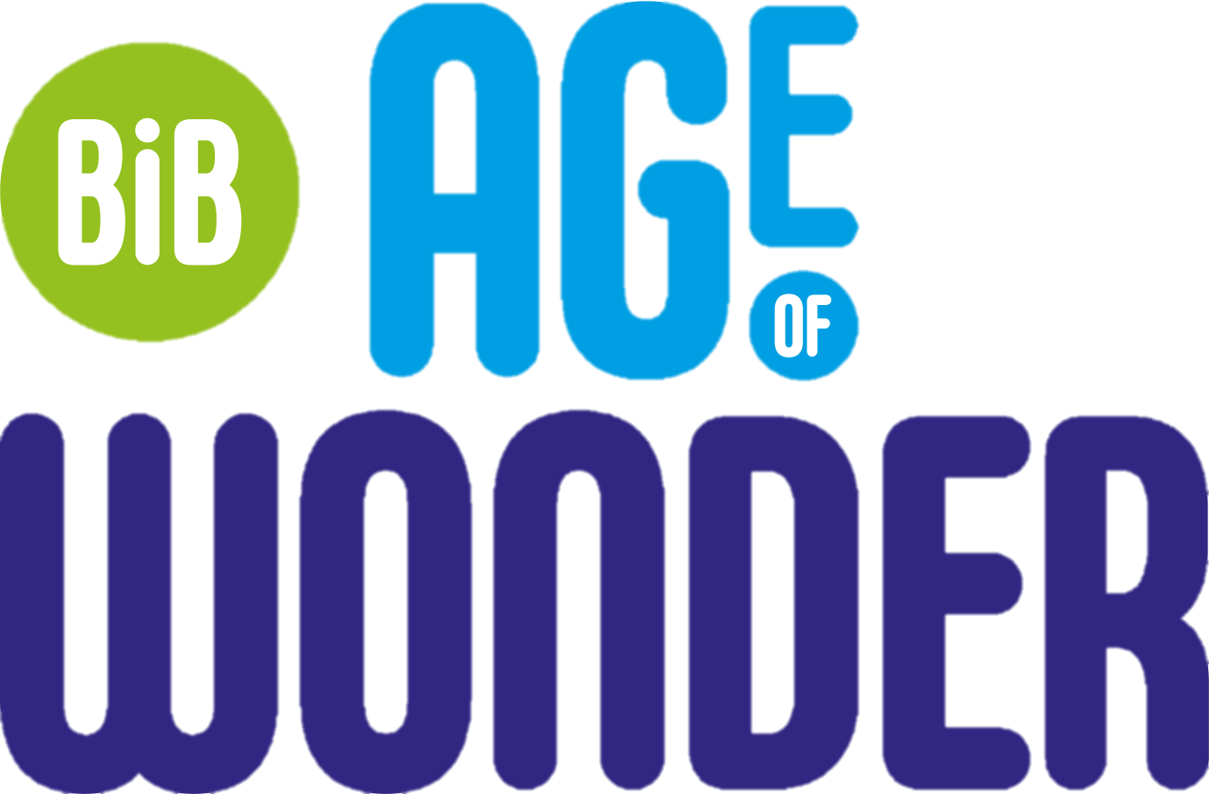
MODULE ONE
CONTENT
Section 1: Demographics
Ethnicity
Language
Religion
Sex and gender identity
Disability

Section 2: Socioeconomics
Material possessions
Family
Economic status
Own financial resources
Food availability
Social comparison
Neighbourhood

Section 3:
Arts and culture

item no. | Items |  |  |  |  | Response format
1 | Participant study ID |  |  |  |  | Text
2 | Year group |  |  |  |  | 8 |  |  |  |  |  |  | 9 |  |  |  |  |  |  |  |  |  |  | 10
Section 1: Demographics
In this section we ask about things like your ethnicity, language and religion. This helps us understand young people’s answers from different backgrounds.
Remember, if you do not want to answer a question, you can skip it.
Item no | Items |  |  |  |  |  |  |  |  | Response format
3 | What is the first letter of your surname? |  |  |  |  |  |  |  |  | Drop down: A-Z
4 | What day of the month is your birthday |  |  |  |  |  |  |  |  | Drop down: 1-26
5 | What is your country of birth? |  |  |  |  |  |  |  |  | Drop down: 200 countries
6 | IF NON UK COUNTRY SELECTED FOR Q5  how many years have you lived In the UK? |  |  |  |  |  |  |  |  | Drop down: 1-15
Ethnicity
Ethnicity is the racial and/or cultural background you associate with (e.g. White-English, Asian-Pakistani) Choose one option then choose one box below to best describe your ethnic group or background.
Item no | Items |  |  |  | Response format
7 | What is your ethnicity? |  |  |  | White; mixed or multiple ethnic groups; Asian or Asian British; black, black British, Caribbean or African; Arab; other ethnic groups
8 | IF SELECTED WHITE TO Q7  Tick one box to best describe your ethnic group or background |  |  |  | English, Welsh, Scottish, northern Irish or British; Irish: Gypsy or Irish traveller: Roma: Polish; Slovakian: Romanian: Czech; Any other White Background (please specify)
9 | IF SELECTED MIXED OR MULTIPLE ETHNIC GROUPS TO Q7  Tick one box to best describe your ethnic group or background |  |  |  | White and black Caribbean; White and black African; White and Asian; Any other mixed or multiple ethnic background (please specify)
10 | IF SELECTED ASIAN OR ASIAN BRITISH TO Q7  Tick one box to best describe your ethnic group or background |  |  |  | Indian; Pakistani; Bangladeshi; Chinese; Any other Asian background (please specify)
11 | IF SELECTED BLACK, BLACK BRITISH, CARIBBEAN, OR AFRICAN Q7  Tick one box to best describe your ethnic group or background |  |  |  | Caribbean; African background (please specify); Any other Black, British or Caribbean background (please specify)
12 | IF SELECTED ARAB TO Q7  Tick one box to best describe your ethnic group or background |  |  |  | Arab; any other ethnic group
Languages
Item no | Items |  |  | Response format
13 | Which of these languages is usually spoken at home? |  |  | English; Urdu; Punjabi; Gujarati; Bengali; Hindko; Polish; Pashto; Other, please specify
14 | IF SELECTED OTHER TO Q13  Other (please specify) |  |  | Text
Religion

15 | Do you consider yourself to have a religion? |  |  | Yes |  |  |  |  |  |  |  |  |  | No
16 | IF ANSWERED YES TO Q15  What is your religion? |  |  | Christianity (including church of England, catholic, protestant and all other Christian denominations); Buddhism; Hinduism; Judaism; Islam; Sikhism; Any other religion (please specify)*
17 | IF ANSWERED OTHER TO Q16  please specify |  |  | Text
Sex and Gender identity
The next questions are about sex and gender identity. In order for our research to be compared with other studies we have used standard measures similar to the National Census. This information is used to monitor equality between groups of people of different genders and sexes. Equality monitoring helps make sure that everyone is treated fairly and helps identify what services are needed. You can choose not to answer any of the questions.
If you feel that there is not an answer that applies to you, there will be a space for you to enter your own response.
Item no | Items |  |  | Response format
18 | What is your sex?(The biological sex on your birth certificate) A question about gender identity will follow in the survey |  |  | Female |  |  | Male |  |  |  |  |  |  | Do not wish to answer |  |  |  |  |  |  |  |  |  |  | Wish to enter own response
19 | IF OWN RESPONSE SELECTED TO Q18  space to self-describe |  |  | Text
20 | What is your gender? |  |  | Female |  |  |  | Male |  |  |  |  |  | Non-binary |  |  |  |  | Wish to enter own response |  |  |  |  |  |  |  |  | Do not wish to answer
21 | IF OWN RESPONSE SELECTED TO Q20  space to self-describe |  |  | Text
Disability
In this section of the survey, you will be asked questions about any disabilities you may have. Remember, If you do not want to answer a question, you can skip it.
Item no | items |  | Response format
22 | Do you have any physical or mental health conditions or illnesses? |  | Yes |  |  |  |  |  |  |  |  |  |  |  | No
23 | IF SELECTED YES TO Q22  Has this lasted, or is it expected to last, for 12 months or more? |  | Yes |  |  |  |  |  |  |  |  |  |  |  | No
24 | IF SELECTED YES TO Q22  Do any of your illnesses or conditions reduce your ability to carry out day to day activities |  | Yes a lot |  |  |  |  |  | Yes a little |  |  |  |  |  |  |  |  |  |  | Not at all
Section 2: Socioeconomics
Material Possessions
In this part of the survey you will be asked questions
about the things you have. Remember, if you do not want to answer a question, you can skip it.
Item no | Items |  |  |  |  |  |  |  |  |  |  | Response format
25  26  27  28  29  30  31  32  33 | Which of these things do you have?  3 meals every day  A warm winter coat  Clothes that you think your friends like  Your own mobile phone  A computer, laptop or tablet with internet at home  At least one family holiday away from home in a typical year  A family car, van or truck  A bedroom for yourself  A dishwasher at home |  |  |  |  |  |  |  |  |  |  | Yes |  |  |  |  |  |  |  |  |  |  | No
34 | Compared to your friends, would you say your family is richer, about the same, poorer or don’t know? |  |  |  |  |  |  |  |  |  |  | Richer |  |  |  | About the same |  |  |  |  | poorer |  |  |  |  |  |  |  | Don’t know
35 | How often do you worry about how much money your family has? |  |  |  |  |  |  |  |  |  |  | Never |  |  |  |  |  | Some of the time |  |  |  |  |  |  |  |  | All of the time
36 | When you are home on a typical day in winter, are you (and everyone in your household) warm enough? |  |  |  |  |  |  |  |  |  |  | Yes- always |  |  |  | Yes- sometimes |  |  |  |  | No- rarely |  |  |  |  |  |  |  | No- never
37 | My parents/ guardians have talked about the need to cut back on certain things to save money |  |  |  |  |  |  |  |  |  |  | Yes |  |  |  |  |  |  |  |  |  | No
38 | IF ANSWERED YES TO Q37  Which of the following have your parents/guardians discussed cutting back on? |  |  |  |  |  |  |  |  |  |  | Using too much energy (eg gas or electric); Luxuries (eg takeaways, eating out, new cars, new clothes ect); Holidays and leisure activities (eg hobbies, outside of school, trips ect); Food shopping; Car journeys to save fuel  Other (please specify)
39 | IF ANSWERED OTHER TO Q.38  Other, please specify |  |  |  |  |  |  |  |  |  |  | Text
Household structure
In this part of the survey you will be asked questions about who you live with.
Remember all your responses are completely confidential, if you don’t want to answer a question, you can skip it
Item no. |  | Items |  |  |  |  |  |  |  |  | Response Format
40 |  | How many homes do you live in? |  |  |  |  |  |  |  |  | 1 |  |  |  |  |  | 2 |  |  |  |  |  |  |  |  | More than 2
41 |  | Who lives in your first home? Tick all that apply. |  |  |  |  |  |  |  |  | Mother; Father; Guardian; Stepmother; Stepfather; Mother’s partner; Father’s partner; Siblings; Auntie; Uncle; Grandmother; Grandfather; Cousins; Other
42 |  | IF ANSWERED OTHER TO Q.41,  Please specify: |  |  |  |  |  |  |  |  | Text
43 |  | DEPENDING ON OPTIONS SELECTED IN Q.41,  How many of your (mothers/fathers/guardians… etc.) live in your first home? |  |  |  |  |  |  |  |  | Number
44 |  | IF SELECTED 2 OR MORE IN Q.40,  Who lives in your second home? Tick all that apply. |  |  |  |  |  |  |  |  | Mother; Father; Guardian; Stepmother; Stepfather; Mother’s partner; Father’s partner; Siblings; Auntie; Uncle; Grandmother; Grandfather; Cousins; Other
45 |  | IF SELECTED ‘OTHER’,  Please specify: |  |  |  |  |  |  |  |  | Text

Family
46 | Select your birth order. I am… | 1st born, 2nd born, 3rd born, 4th born, 5th born, 6th born, 7th born, 8th born, 9th born, 10th born.
47 | How many of your (mothers/fathers/guardians… etc.) live in your second home? | Number
48 | How often do your family get along together? | Never | Some of the time |  | Always
49 | How often do you get along with your brothers, sisters, and other young people you live with? | Never | Some of the time | Always | I don’t live with any siblings
Economic status
In this part of the survey you will be asked questions about who in your home works. Remember, if you do not want to answer a question, you can skip it.
50 | Do any of the adults looking after you in your first home have a job? | Yes | No |  | Don’t know
50  51  52 | IF ANSWERED YES TO Q50,  For up to three of the adults living in your first home who have jobs…  What is their relation do you?  What is their place of work? (e.g. hospital, bank, restaurant)  What job do they do? (e.g. teacher, bus driver) | Dropdown options  Text box  textbox
53 | IF ANSWERED NO TO Q50,  Why do the adults in your first home not have a job? Please tick all that apply. | They are sick, retired or a student | They are looking for a job | They take care of others or are full-time at home | Don’t know
54 | IF SELECTED ‘2’ OR ‘More than 2’ IN Q.40,  Do any of the adults in your second home have a job? | Yes | No |  | Don’t know
55  56  57 | IF ANSWERED ‘YES’ TO Q.55,  For up to three of the adults living in your second home who have jobs…  What is their relation do you?  What is their place of work? (e.g. hospital, bank, restaurant)  What job do they do? (e.g. teacher, bus driver) | Dropdown options  Text  Text
Own Financial Resources
In this part of the survey you will be asked questions about your own money.
Remember, all of your responses are completely confidential. If you do not want to answer a question, you can skip it.

Item no | Items | Response Format:
58. | Do you get money to spend money to spend on yourself from any of the following sources?
59. | Regular pocket money or allowance | Yes | No
60. | Money from doing chores or babysitting for family or relatives | Yes | No
61. | Money from working in the family business | Yes | No
62. | Money from a paid job | Yes | No
63. | Given money by parents when I need it | Yes | No
64. | I never get any money to spend on myself | Yes | No
65. | Other | Yes | No
66. | IF ANSWERED YES TO Q146  Space to self-describe | Text box

Food Availability
In this part of the survey you will be asked questions about the availability of food to you.
Your answers will help local organisations support people’s access to food in your community and across Bradford.
Remember, all of your responses are completely confidential. If you do not want to answer a question, you can skip it.

Item no | Item | Response Format
67. | We can’t get the food we want because there is not enough money | Yes | No
68. | I worry about not having enough to eat | Yes | No
69. | I worry about how hard it is for my parents to get enough food for us | Yes | No
70. | I feel hungry because there is not enough food to eat | Yes | No
71. | I try not to eat a lot so that our food will last | Yes | No
Social Comparison
In this part of the survey you will be asked questions about how you feel about comparisons people make between each other.
Remember, all of your responses are completely confidential. If you do not want to answer a question, you can skip it.

Item no | Item | Response Format
 | How often do you think the following?
72. | If I don’t strive to achieve I will be seen as inferior to other people | Never | Rarely | Mostly | Sometimes | Always
73 | People compare me to others to see if I match up | Never | Rarely | Mostly | Sometimes | Always
75. | Others will accept me even if I fail | Never | Rarely | Mostly | Sometimes | Always
Neighbourhood
This part of the survey will ask you questions about your neighbourhood. Remember, if you do not want to answer a question, you can skip it.

Item no | Item | Response Format
76. | How do you rate the following in the area that you live?
77. | Your safety when going out after dark | Very poor | Poor | Ok | Good | Very good
78. | Your safety when going out during the day | Very poor | Poor | Ok | Good | Very good
79. | Your safety at school | Very poor | Poor | Ok | Good | Very good
80. | Your safety when going to or from school | Very poor | Poor | Ok | Good | Very good
81. | In the last 12 months have you been the victim of violence or aggression in the area where you live? | No | Not sure | Yes
82. | To what extent do you agree or disagree with the following statement:  I can influence decisions affecting my local area | Strongly Agree | Agree | Neither agree nor disagree | Disagree | Strongly Disagree | Don’t have an opinion | Don’t know
Arts and Culture
Activities in this section will be asking all about your involvement in arts and culture activities.

Your answers will help local organisations identify which arts and culture activities are the most relevant to young people, and how organisations can support young people to engage in these activities.

Item no | Item |  |  |  |  | Response Format
Did you do any of the following activities in the last month?
83. | Go to a party, dance, house party or nightclub |  |  |  |  | Yes |  |  | No
84. | Go to watch live sport (for example at a stadium) |  |  |  |  | Yes |  |  | No
85. | Sing, play an instrument, or make music (either on your own or as part of a choir/band/orchestra) |  |  |  |  | Yes |  |  | No
86. | Go to a live music concert or gig |  |  |  |  | Yes |  |  | No
87. | Go to some other type of live performance, such as a play, pantomime, opera, dance or circus |  |  |  |  | Yes |  |  | No
88. | Read for enjoyment |  |  |  |  | Yes |  |  | No
89. | Go to youth clubs |  |  |  |  | Yes |  |  | No
90. | Go to explorer scouts/senior guides |  |  |  |  | Yes |  |  | No
91. | Go to a library |  |  |  |  | Yes |  |  | No
92. | Go to museums or galleries, visit a historic place or stately home |  |  |  |  | Yes |  |  | No
93. | Do voluntary, charity or community work |  |  |  |  | Yes |  |  | No
94. | Go to a political meeting, march, rally or demonstration |  |  |  |  | Yes |  |  | No
95. | Attend a religious service or event |  |  |  |  | Yes |  |  | No
96. | Participate in a poetry/spoken word session |  |  |  |  | Yes |  |  | No
97. | Do creative writing (outside work or school) |  |  |  |  | Yes |  |  | No
98. | Take part in theatre, dance, circus, or other performance activities |  |  |  |  | Yes |  |  | No
99. | Make your own drawing, painting, sculpture or other artwork (things that are made by hand) |  |  |  |  | Yes |  |  | No
100. | Make your own graphic designs, photographs, or films/videos (things that are made using digital technology, including content for social media such as Instagram or TikTok) |  |  |  |  | Yes |  |  | No
101. | Are there any cultural activities that you do that you would like to tell us about? |  |  |  |  | Text box
102. | What motivates you to participate in artistic or cultural activities? You can choose more than one option. |  |  |  |  | I enjoy the activity; It’s an opportunity to socialise with my friends; To improve my skills/develop some talent; To feel better emotionally; To express emotions and opinions through art; Other (please specify)
103. | IF ANSWERED OTHER TO Q203  Space to self-describe |  |  |  |  | Text
104. | If there are activities from the list above that you would like to do, but don’t do at the moment, what are the reasons for not doing them? You can choose more than one option. |  |  |  |  | I do not have enough time; It is too expensive; I have health problems that prevent me from participating; There are no facilities to do artistic activities in my local area; I can’t find information about the activities on offer; The closest facility/arts academy is too far away; I’m not interested in the arts; Other (please specify)
105. | IF ANSWERED OTHER TO Q205.  Space to self-describe |  |  |  |  | Text
Please complete the following questions with a maximum of three artistic activities that you have done in the last 30 days
106. | Activity 1 | Attend party, dance, house party or night club; Watch live sport; Sing, play instrument, or make music; Watch live music or gig; Watch play, pantomime, opera, dance or circus; Read for enjoyment; Attend youth club; Attend explorer scouts/senior guides; Visit library; Visit museums, galleries, or place of historical significance; Voluntary, charity, or community work; Political meeting, march or rally; Attend religious service; Participate in poetry/spoken word session; Creative writing (outside school); Perform theatre, dance, circus; Make drawing, painting, sculpture; Make graphic designs, photographs, films/videos
107. | Who are you doing this activity with? | Alone |  | With friends |  |  |  | Others (please specify)
108. | IF ANSWERED OTHER TO Q208.  Space to self-describe | Text
109. | Where do you do this activity? | School/College or higher education; Work; Arts academy or club; Local community centre; Church; At home/virtual; Other (please specify)
110. | IF ANSWERED OTHER TO Q210.  Space to self-describe | Text
111. | Activity 2 | Attend party, dance, house party or night club; Watch live sport; Sing, play instrument, or make music; Watch live music or gig; Watch play, pantomime, opera, dance or circus; Read for enjoyment; Attend youth club; Attend explorer scouts/senior guides; Visit library; Visit museums, galleries, or place of historical significance; Voluntary, charity, or community work; Political meeting, march or rally; Attend religious service; Participate in poetry/spoken word session; Creative writing (outside school); Perform theatre, dance, circus; Make drawing, painting, sculpture; Make graphic designs, photographs, films/videos
112. | Who are you doing this activity with? | Alone |  | With friends |  |  |  | Others (please specify)
113. | IF ANSWERED OTHER TO Q213  Space to self-describe | Text
114. | Where do you do this activity? | School/College or higher education; Work; Arts academy or club; Local community centre; Church; At home/virtual; Other (please specify)
115. | IF ANSWERED OTHER TO Q215.  Space to self-describe | Text
116. | Activity 3 | Attend party, dance, house party or night club; Watch live sport; Sing, play instrument, or make music; Watch live music or gig; Watch play, pantomime, opera, dance or circus; Read for enjoyment; Attend youth club; Attend explorer scouts/senior guides; Visit library; Visit museums, galleries, or place of historical significance; Voluntary, charity, or community work; Political meeting, march or rally; Attend religious service; Participate in poetry/spoken word session; Creative writing (outside school); Perform theatre, dance, circus; Make drawing, painting, sculpture; Make graphic designs, photographs, films/videos
117. | Who are you doing this activity with? | Alone |  | With friends |  |  |  | Others (please specify)
118. | IF ANSWERED OTHER TO Q219.  Space to self-describe | Text
119. | Where do you do this activity? | School/College or higher education; Work; Arts academy or club; Local community centre; Church; At home/virtual; Other (please specify)
120. | IF ANSWERED OTHER TO Q220.  Space to self-describe | Text
121. | How much do you agree with the following statement?  I have great talent in artistic activities. | Strongly agree | Agree |  | Neither agree nor disagree |  | Agree |  |  | Strongly agree

