

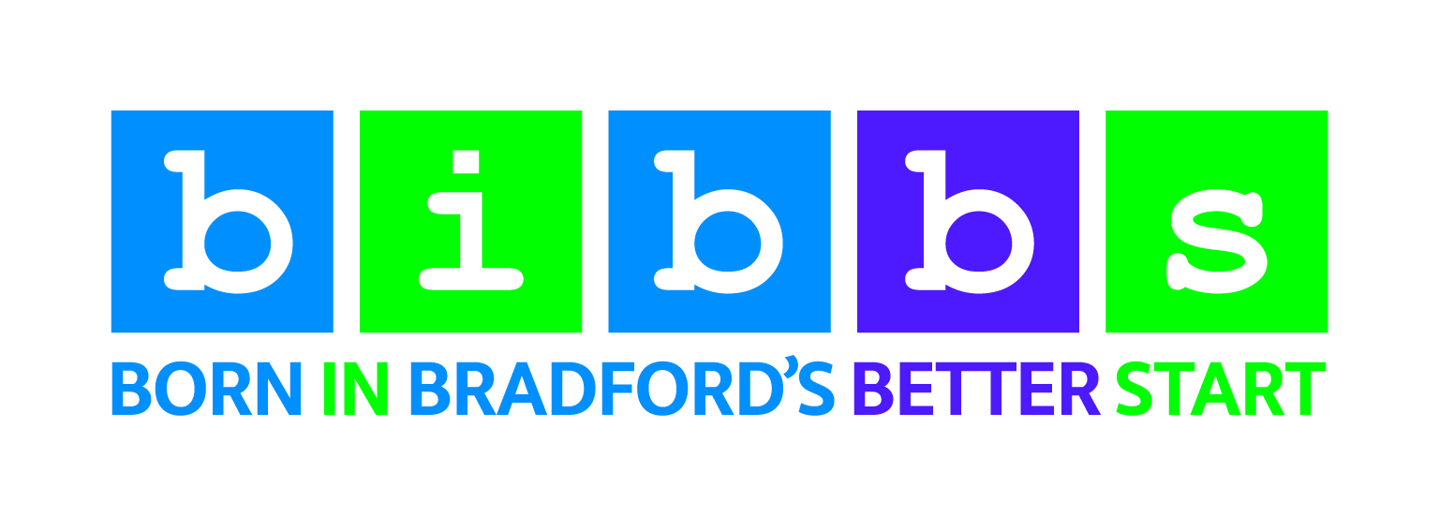


Participant information sheet for team leaders
Study Title: Examining the impact of continuity of carer for midwives and women.

What is the purpose of this study?
We would like to invite you to take part in a study to explore team leaders’ experiences of giving Continuity of Carer midwifery-led support to women across the antenatal, intrapartum and postnatal periods. We would grateful if you could take some time to read this information sheet that tells you more about it.
If there is anything that is not clear you can contact the researchers (contact details below).

Why have I been chosen?
You have been chosen because you are a continuity of carer team leader working at Bradford Royal Infirmary within either the Clover or Heather team.

Do I have to take part?
No. It is up to you to decide whether you want to take part.

What will happen to me if I take part?
We will ask you to complete 4 reflective diaries online. The diaries will ask you some reflective questions to get your thoughts and experiences of managing a team of continuity of carer midwives. We anticipate that each diary will take no longer than one hour to complete, however, you may choose to spend longer completing it. You will be able to complete the diary over multiple sittings if you wish.
Our research team will send you a unique web link to complete the diary if you would like to take part. If you want to complete your diary on different days, you will be able to return to your diary by clicking the web link you have been sent. You will be asked to complete one diary every 3 months (4 diaries in total).

Will my taking part in the study be kept confidential?
Yes. We will not ask you to provide your name or contact details when you complete the diary.
In your diaries, we will ask you not to include personal details about you or any woman/family/midwife that you may be referring to when describing your recent experiences of providing care.
If however, you do accidentally include some personal details, we will remove these details and replace with pseudonyms (false names). Only researchers involved in this study will be able to identify the personal details that were included. The actual data from your diaries will be stored securely for 10 years after the study has taken place.

What will happen if I do not want to carry on with the study?
You are free to withdraw from this study at any time. Each individual that completes a diary will be asked to complete it anonymously (i.e., without including any personal/identifiable information) therefore, we will be unable to exclude any reflective diaries that you may have completed, if you later decide to withdraw from the study.

What will happen to the results of the research study?
We will share the findings with Better Start Bradford, the midwifery services at BTHFT and local CCG commissioners. We hope to publish the results of this study in an academic journal. It is also possible that findings from this study may be presented at conferences. You will not be able to be identified from your diary responses.
If you wish to obtain a copy of any publications, you can request one from one of the researcher(s) or visit our website (www.borninbradford.nhs.uk).
Who is organising and funding this study?
This study is being completed as part of the evaluation of the Personalised Midwifery Care, commissioned by Better Start Bradford and funded by the Big Lottery.

Contact details
If you have any questions or would like more information, please contact Dr Rachael Moss at the Better Start Bradford Innovation Hub by emailing rachael.moss@bthft.nhs.uk or phoning 01274 364474.
Thank you very much for taking the time to read this sheet and for thinking about taking part in the study.

